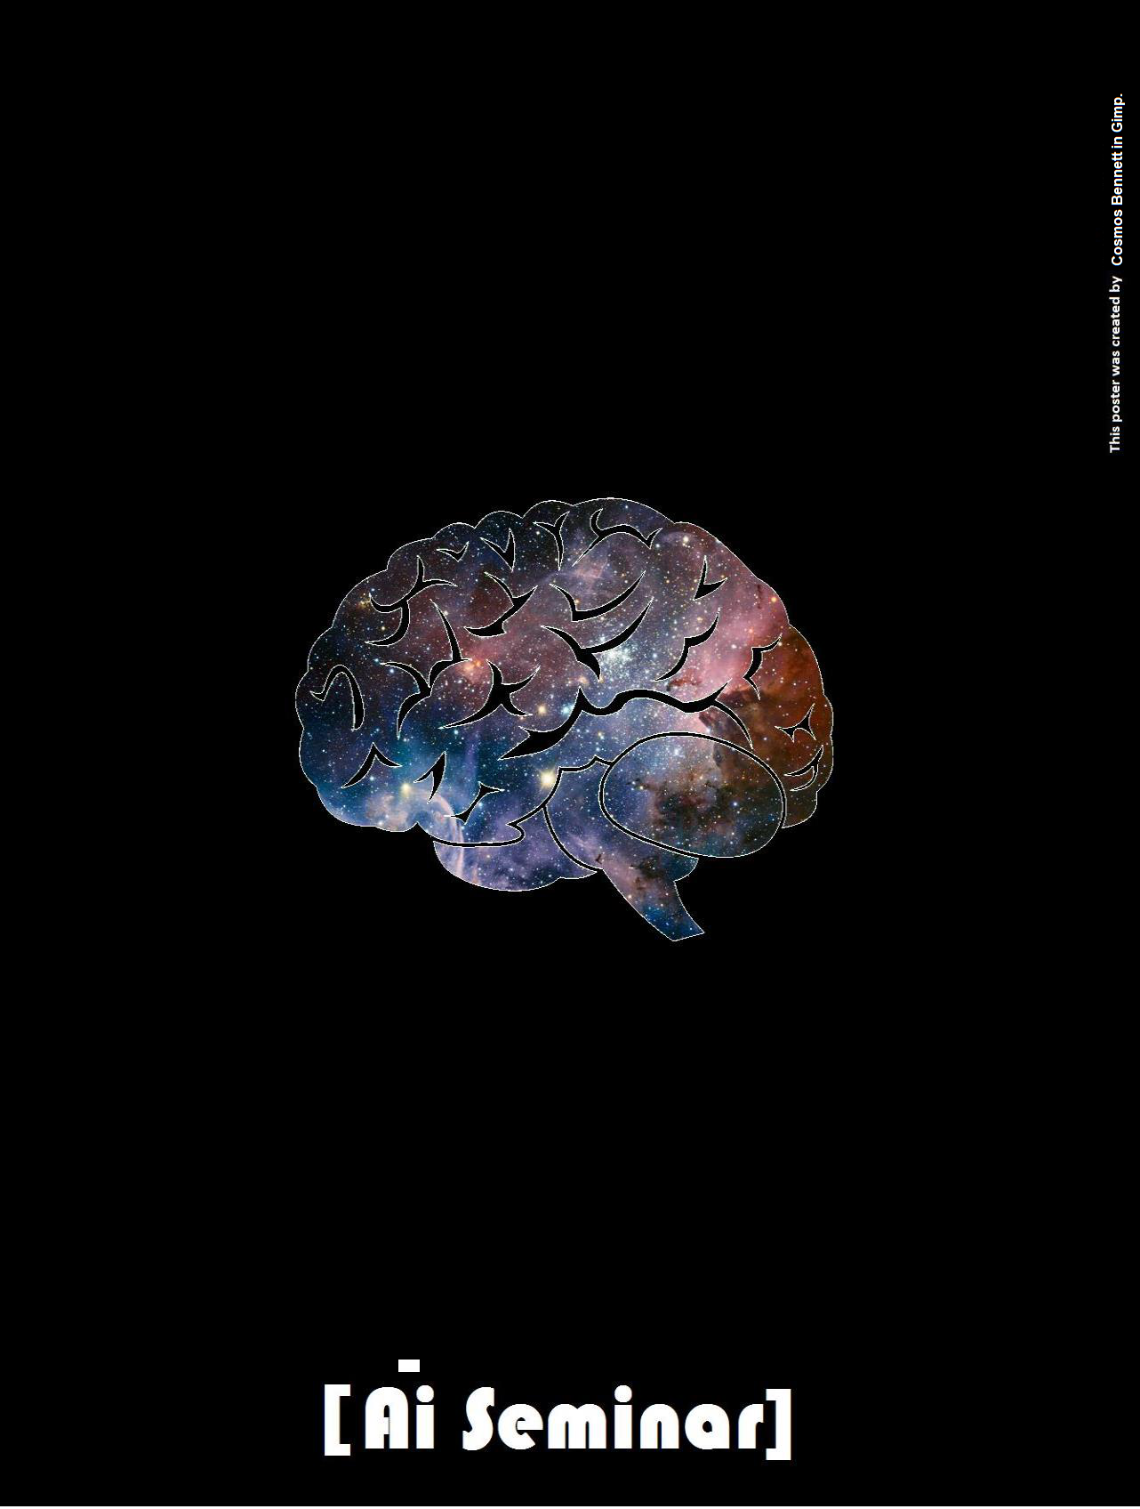

Bank Artificial Intelligence

Seminar

**A small seminar featuring a live Ai session, where a basic** [**Artificial Neural Network w**](https://en.wikipedia.org/wiki/Artificial_neural_network)**as written from scratch & discussed, led by Cosmos Bennett**

2020 to 2024

Code/video for a liverecordedsessionofa basic neuralnetworkdonebyCosmos Bennett<https://www.youtube.com/watch?v=OhRkCb8XGj0>

Brain inspired computer code or smart apps, called **AGI or ArtificialGeneralIntelligence**(predicted tohappenby [as soon as 2029](http://www.businessinsider.com/ray-kurzweil-thinks-well-have-human-level-ai-by-2029-2014-12)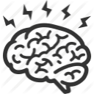

[or sooner),](http://www.businessinsider.com/ray-kurzweil-thinks-well-have-human-level-ai-by-2029-2014-12)will perhaps oneday be [mankind's last invention! (](https://www.youtube.com/watch?v=9snY7lhJA4c)Interested partiescan see *MIT’sAGI course* [*here.)*](https://agi.mit.edu/)

For now though, AGI's predecessor,

called **ArtificialNarrow Intelligence**,alsocalled**Artificial Intelligence**, cando amazing stuff like [diagnosediseasesbetter than human doctors,](https://futurism.com/ai-diagnose-heart-disease-lung-cancer-more-accurately-doctors/) enable [self drivingcars, o](https://www.youtube.com/watch?v=Eq89YGbERzs)r [give game characters the abilityto learn to](https://www.youtube.com/watch?v=qv6UVOQ0F44) [navigategame environmentswithouthuman aid!](https://www.youtube.com/watch?v=qv6UVOQ0F44)

Crucially[,*whereAi is alreadyenhancingbanking*,f](https://www.entrepreneur.com/article/319921)ortunately [the **Jamaicangovernment**has recognized the impact that artificial](http://www.jamaicaobserver.com/news/2019-and-beyond-what-to-expect-from-artificial-intelligence_153343)

[intelligence alreadybrings,and what shall likelyhappen futureward.I](http://www.jamaicaobserver.com/news/2019-and-beyond-what-to-expect-from-artificial-intelligence_153343) speak moreabout this in the gleanerarticlesfound on the newspaper tab [on this experimental platformof mine.](http://mlj-institute.rf.gd/)

**Quick Overview of Seminar:**

1.) All of successful artificial intelligence algorithms today perform something called [error minimization.](https://www.edge.org/response-detail/27122)

2.) They work ***similar*** to how biological brains work.

3.) For eg, with a ***high error rate***, a child will first ***wrongly*** identify objects in the world in his/her earlier years of life.



3.b.) That error rate gets ***smaller*** or is minimized, as the child gets better at identifying objects in the world; in the early years, a parent can guide the child by saying this is a cat or this is a dog etc, i.e. the parent helps the child to ***correctly label*** objects in world.

3.c.) After a while, even without parental guidance, the child will be quite good at identifying objects, and his/her error rate at object identification would have been ***minimized substantially.***

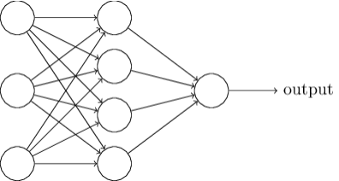

4.) Artificial Intelligence works in a similar way; for a particular task, they start out ***terrible*** with high error rates, then they get far better after being exposed to many instances of correctly labelled things, until they get to a point of doing the task well, even without being exposed to correctly labelled data.

***5.) Artificial neural networks power most smart apps today.***

**I spent about 2 hours to write a basic artificial neural network in java from scratch without using machine libraries/internet. (The aim was to try to guide SASS team along in writing a basic artificial neural network, as I wrote the code)**

This exercise was really geared towards preparing more Bank programmers to better apply machine learning libraries.

6.) Though optional, understanding basic neural nets (even a non-math heavy, but programmatic understanding instead) can afford the programmer better grasp of applying machine learning libraries such as ***tensorflow*** built by Google or ***azure ml*** by Microsoft or other ones by other parties like [**the one I**](http://pasi.jncb.com/bennettjm/Artificial_Intelligence_Based_Credit_Card_Fraud_Detection_Layer)[**used to help code the artificial neural network based credit card fraud**](http://pasi.jncb.com/bennettjm/Artificial_Intelligence_Based_Credit_Card_Fraud_Detection_Layer)[**detection system demo here at National Commercial Bank**. (](http://pasi.jncb.com/bennettjm/Artificial_Intelligence_Based_Credit_Card_Fraud_Detection_Layer)We ***didn't*** go through [the math behind basic neural nets, b](https://www.researchgate.net/publication/321162382_Artificial_Neural_Nets_For_Kids)ut we went through a relatively simple live programming example instead.)

Regards,

Cosmos Bennett (author of the weekly Jamaican-newspaper Gleaner column: ["ArtificialIntelligenceand the](http://jamaica-gleaner.com/article/news/20180604/artificial-intelligence-and-economy-utilising-artificial-intelligence-could) [economy",](http://jamaica-gleaner.com/article/news/20180604/artificial-intelligence-and-economy-utilising-artificial-intelligence-could)and [“Why Jamaica needs a minister of Ai”](https://jamaica-gleaner.com/article/news/20191229/why-jamaica-urgently-needs-minister-artificial-intelligence)…,inventor of the ["SupersymmetricArtificialNeural](https://github.com/JordanMicahBennett/Supersymmetric-artificial-neural-network) [Network" a](https://github.com/JordanMicahBennett/Supersymmetric-artificial-neural-network)nd author of ["ArtificialNeural Networks for kids".](https://www.researchgate.net/publication/321162382_Artificial_Neural_Nets_For_Kids)